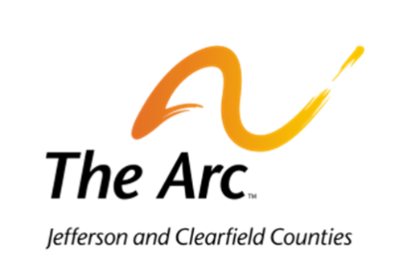
Camp Friendship
8 Oven Road
Reynoldsville, PA 15851

Carla Ferko
Executive Director
212 W. Mahoning Street
Punxsutawney, PA 15767
carlajcarc@gmail.com Camp Friendship Rental Polices
814.952.2467

- Camp Friendship was purchased for and is utilized for the benefit of individuals and families with an intellectual, developmental, and/or physical disability. Profits from rentals are used to offer programs and services to those individuals through our camp.
- The Arc of Jefferson and Clearfield Counties assumes no responsibility for personal property, property damage, and/or personal injury incurred with using the Camp Friendship facilities.
- Cancellations must be made 15 days in advance or deposits will be forfeited.
- All rentals are daily.
- Alcohol is not permitted on the premises.
- Smoking is only permitted outside of buildings. Please exercise extreme caution when smoking outdoors at our camp facility.
- Swimming in or use of the pond is prohibited.
- Rental groups are responsible for any damages incurred and/or will result in loss of deposit, as determined by the Executive Director.
- Rental groups will assume liability for injuries to persons attending the rental event. Rental groups also agree to hold harmless The Arc of Jefferson and Clearfield Counties for any and all accidents involving bodily injury or property damage to those utilizing the facilities during the rental period.
- Rental groups are required to follow Camp Cleaning Rules posted within the facilities.
- Users are expected to leave the camp and any items used clean and in the same condition prior to usage.
- Dining Area-tables cleaned, floors swept and mopped
- Kitchen-cleaned, swept and mopped
- Downstairs Area-cleaned and floors swept if utilized
- Trash removed from facility and placed in dumpster
- All items associated with rental removed from the premises

